- SUMMARY OF LAB 2

Software Setup
- Before anything else, we opened Proteus 8 and started a new ISIS schematic project. Proteus ISIS is the schematic capture and simulation environment within the Proteus suite. It works like a virtual electronics workbench — you place components on a canvas, wire them together, attach virtual instruments, and then hit play to run the simulation in real time

- Experiment 1
- Circuit Construction
- Circuit A was the simpler of the two. R1 (5.1 kΩ) and R2 (3.3 kΩ) were connected one after the other in series, forming a single loop with the voltage source V1. There are no branches or parallel paths — current has only one route to flow through, which means the exact same current passes through R1 and R2 at every instant in time.
- The source was configured as described above — 2.5V peak amplitude (5V p-p), 100 Hz, giving a period of T = 1/100 = 10 milliseconds

.
- Running the Simulation and Reading the Oscilloscope

- Once the simulation was started with F12, the oscilloscope window opened and three waveforms appeared simultaneously — the input across V1, the voltage across R1, and the voltage across R2. All three were clean, smooth sinusoids. Immediately visible was that the R1 waveform had a larger amplitude than R2, because R1 has a higher resistance and therefore takes a larger share of the total voltage.
- To measure the peak-to-peak voltage on each channel, we used the oscilloscope cursors. Cursor 1 was placed at the positive peak of the waveform and Cursor 2 at the negative peak. The delta-V reading between the cursors gave the p-p voltage directly. For the period, we placed the two cursors at consecutive rising zero-crossings and read the delta-T value.
- A key observation at this stage was that all three waveforms — input, V_R1, and V_R2 — were perfectly in phase with each other. There was no time delay or phase shift between them at all. This is the defining characteristic of a purely resistive circuit: resistors do not store energy (unlike capacitors or inductors), so they cannot cause any phase difference between voltage and current.
- Calculations for Experiment 1

- With the oscilloscope readings confirmed, we worked through the theoretical calculations to verify them.
- The total resistance of the series circuit is simply the sum of the two resistors: R_total = R1 + R2 = 5100 + 3300 = 8400 Ω (8.4 kΩ)
- Using the voltage divider rule, which states that each resistor in a series circuit drops a fraction of the total voltage equal to its fraction of the total resistance:
- For R1: V_R1 (p-p) = 5.0 × (5100 / 8400) = 3.036 V p-p V_R1 (RMS) = (3.036 / 2) / √2 = 1.074 V RMS
- For R2: V_R2 (p-p) = 5.0 × (3300 / 8400) = 1.964 V p-p V_R2 (RMS) = (1.964 / 2) / √2 = 0.695 V RMS
- Input signal RMS: V_in (RMS) = (5.0 / 2) / √2 = 1.768 V RMS

- Experiment 2
- Circuit Construction

- Circuit B was more involved. R1 (4.7 kΩ) was placed in series as before, but this time the output end of R1 was connected to a parallel combination of R2 (3.3 kΩ) and R3 (5.1 kΩ). In Proteus, this meant wiring R2 and R3 side by side between the same two nodes — Node A at the top and Node B at the bottom — and connecting Node A to the junction of R1 and the rest of the circuit.
- The source was reconfigured to 3.5V peak (7V p-p) at 200 Hz, giving a period of T = 1/200 = 5 milliseconds.
- We also added more oscilloscope probe points for this experiment — one across R1, one across R2, one across R3, one across R1 and R2 combined, and one across R2 and R3 combined, in addition to the input channel.
- Running the Simulation and Reading the Oscilloscope
- When the simulation ran, five distinct waveforms were visible. The most immediately striking result was that the waveforms across R2 and R3 were completely identical — same amplitude, same phase, perfectly overlapping. This is because R2 and R3 are connected in parallel: they share the exact same two nodes, so by definition they always have the same voltage across them regardless of their individual resistance values. This is a fundamental rule of parallel circuits and Proteus demonstrated it visually and unambiguously.
- The waveform across R1 was larger in amplitude than R2 or R3, because R1 carries the full circuit current while R2 and R3 each carry only a portion of it. The combined waveform across R1 + R2 was equal to the full input — which makes sense because R1 and the parallel pair together span the entire circuit.
- Calculations for Experiment 2

- This experiment required a two-step resistance calculation.
- First, calculate the equivalent resistance of the parallel pair R2 ∥ R3: R_23 = (R2 × R3) / (R2 + R3) = (3300 × 5100) / (3300 + 5100) = 16,830,000 / 8400 = 2003.6 Ω ≈ 2.004 kΩ
- Then the total circuit resistance: R_total = R1 + R_23 = 4700 + 2004 = 6704 Ω (6.704 kΩ)
- Now apply the voltage divider rule to find the voltage across each section:
- Voltage across R1: V_R1 (p-p) = 7.0 × (4700 / 6704) = 4.907 V p-p V_R1 (RMS) = 4.907 / (2 × √2) = 1.737 V RMS
- Voltage across the parallel pair (R2 and R3 both get this): V_23 (p-p) = 7.0 × (2004 / 6704) = 2.093 V p-p V_R2 = V_R3 = 2.093 V p-p, RMS = 0.741 V
- For the combined measurements: V (R1 + R2) = 4.907 + 2.093 = 7.000 V p-p (equal to full supply — KVL confirmed) V (R2 + R3) = 2.093 V p-p (both are across the same parallel node, so the combined voltage is just that node voltage)
- Circuit current: I_peak = V_peak / R_total = 3.5 / 6704 = 0.522 mA I_RMS = 2.475 / 6704 = 0.369 mA
- Power dissipated across the whole circuit: P_total = V_RMS² / R_total = (2.475)² / 6704 = 0.914 mW
- Power breakdown: P_R1 = I_RMS² × R1 = (0.000369)² × 4700 = 0.640 mW P_R2 = V_23_RMS² / R2 = (0.741)² / 3300 = 0.166 mW P_R3 = V_23_RMS² / R3 = (0.741)² / 5100 = 0.108 mW Check: 0.640 + 0.166 + 0.108 = 0.914 mW ✓ — energy conservation confirmed.

- Reading Waveform Parameters — General Procedure
- Regardless of which circuit was being tested, the oscilloscope reading procedure was always the same:
- To find peak-to-peak voltage: count the number of vertical divisions between the top peak and the bottom peak of the waveform, then multiply by the Volts/Div setting on that channel. For example, if the waveform spans 7 divisions and the setting is 1 V/div, then V_pp = 7.0 V.
- To find RMS voltage: first get V_peak = V_pp / 2, then V_RMS = V_peak / √2. This conversion only works for pure sinusoidal signals, which is exactly what we had since the source was a VSINE and all loads were purely resistive.
- To find period and frequency: count the number of horizontal divisions for one complete cycle (from one zero-crossing to the next same-direction zero-crossing, or from peak to peak), multiply by the Time/Div setting to get the period T in seconds, then take f = 1/T to get frequency in Hz.
- To verify Ohm's Law: once you have V_RMS across a known resistor, I = V/R gives the current in that branch. This was cross-checked against the theoretical current from the total circuit calculation.

SCREEN SHOTS OF PROTEUS
EXPERIMENT 1
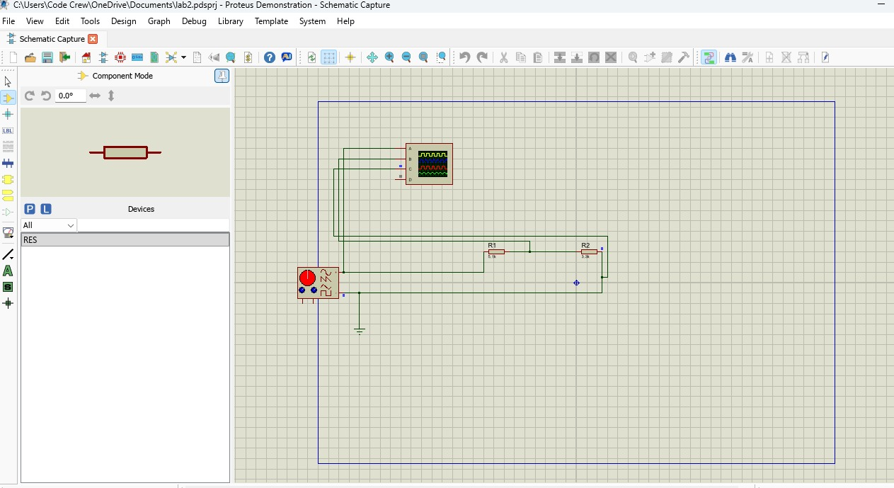

EXPERIMENT 2
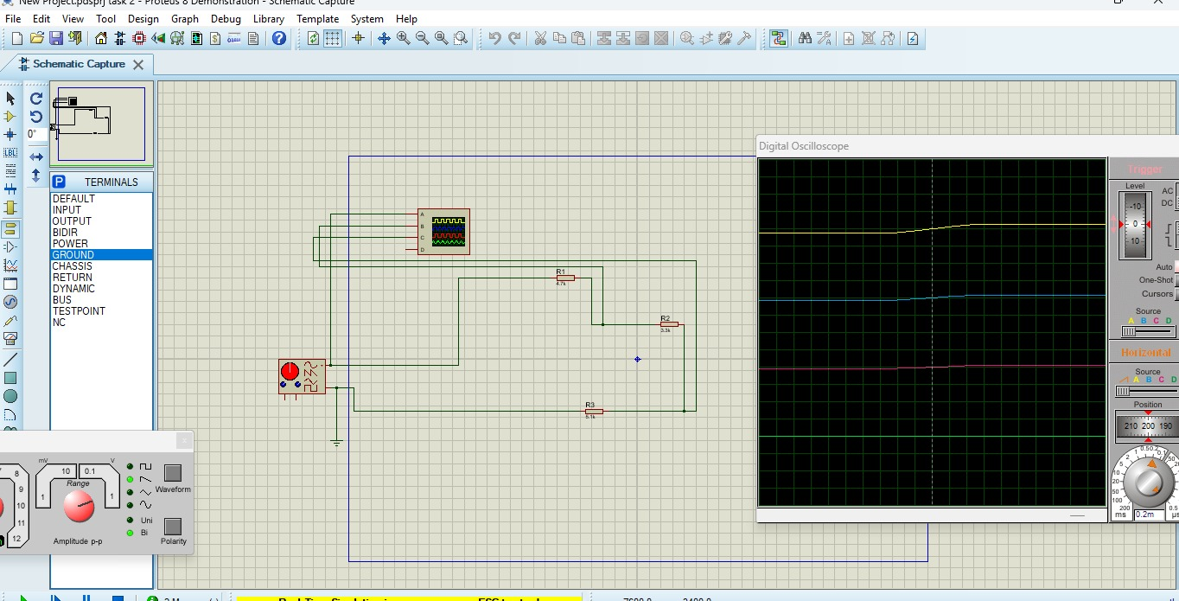S

